1. Save your HTML form as a PHP page in your application directory. And reload it as a PHP file.

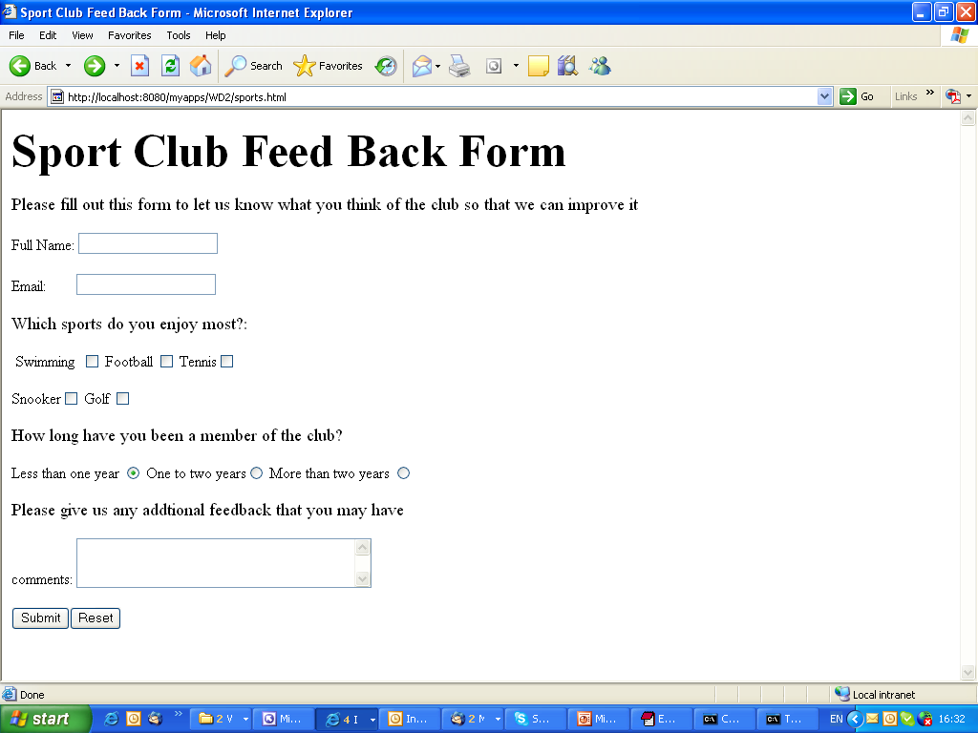

2. Single quotes and double quotes don't work the same way in PHP.Create a PHP file like below, see the output of the script. Replace the echo line with :

echo ‘What goes $around comes $around.’;

What will happen?

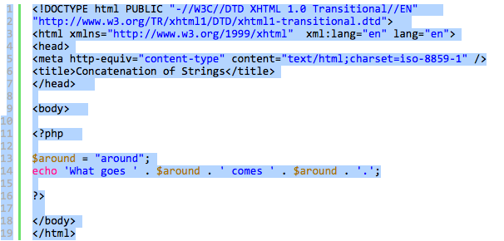

3. $color = array('white', 'green', 'red', 'blue', 'black');  
Write a script which will display the following string "The memory of that scene for me is like a frame of film forever frozen at that moment: the red carpet, the green lawn, the white house, the leaden sky. The new president and his first lady. - Richard M. Nixon"

and the words 'red', 'green' and 'white' will come from $color.

4. Using ternary operator to create a PHP page to detect if three conditions (eg. 5 > 6; $a1 == false ) is true or false, then print out three different results.

5. Rewrite the “Equality” and “Identity” two examples from lecture notes to see if it can produce different results if change some of the conditions.